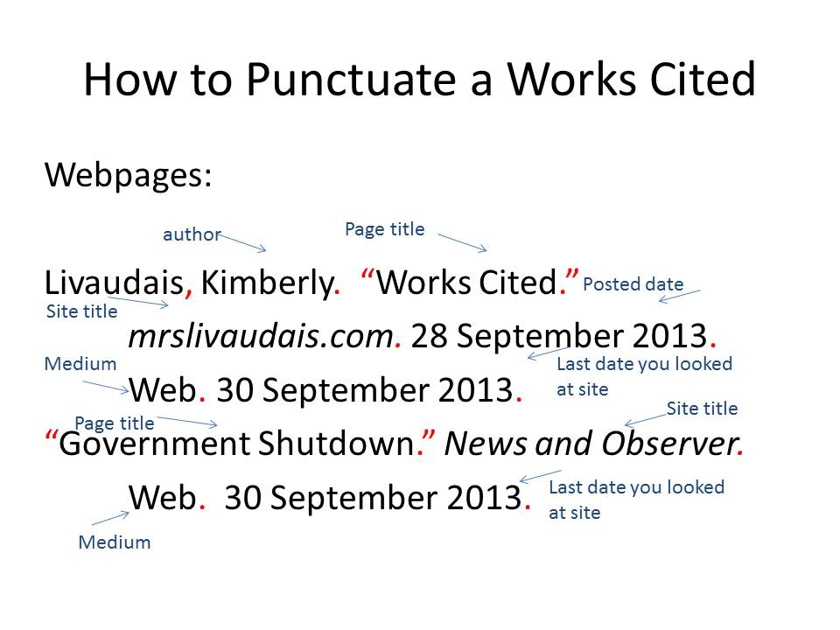
MLA Citations
http://www.citationmachine.net/
Citation Machine (learn how to use it)
Title of Article
https://owl.english.purdue.edu/owl/resource/747/08/
Works Cited Sources
https://owl.english.purdue.edu/owl/resource/747/01/
MLA Style Guide by Owl Purdue (use menu on the left to go to specific question)
http://content.easybib.com/citation-guides/mla-format/how-to-cite-a-photo-digital-image-mla/
Citing a photograph-
(scroll down to “citing a photograph found on a website”)
