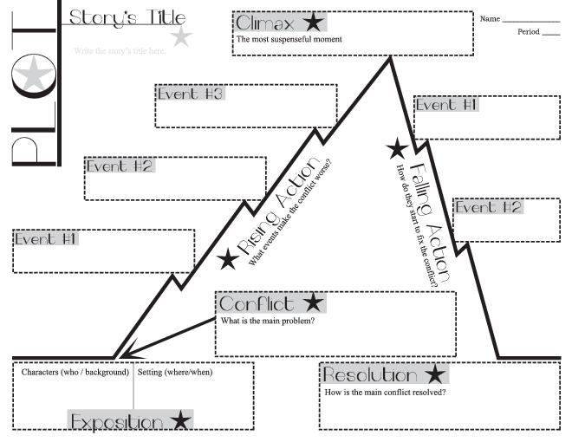

Act III

Act IV

Act II

Act I