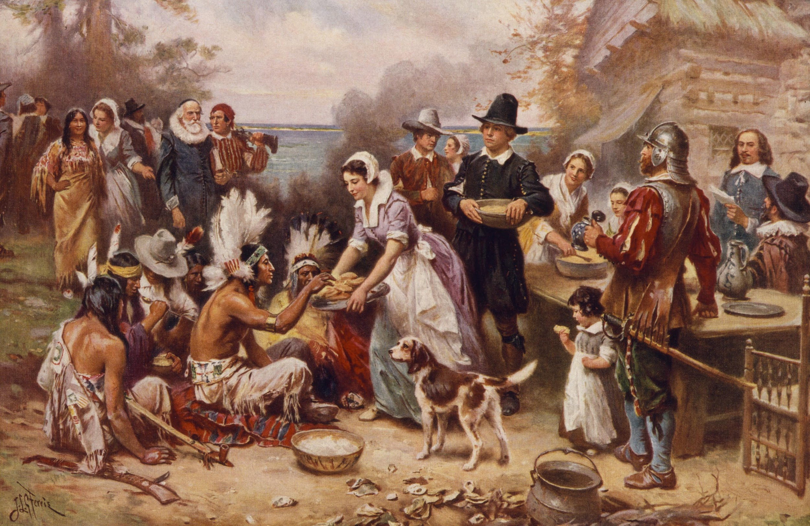 Narrative Unit Summative
Please do not write on this paper. Please write your narrative on a separate sheet of paper. Begin with a proper heading including your name, class/period, English 5/6, and today’s date.
Please do not talk during this quarterly assessment. Complete the planning sheet prior to writing your narrative. It will be graded as well, so make sure your name is on it.
Prompt- Write a fictional narrative about a time-traveler who journeys from 2016 to the 1400-1600’s. He/she is on a mission to change an event in colonial, American history. Your narrative should be 500-1000 words.

From our reading this unit, choose one of the following events for your time-traveler to change:
- Columbus’s arrival to the New World
- The voyage of the Mayflower (Mayflower Compact)
- The Pilgrim or Puritan’s first month in the New World
- The first Thanksgiving (Of Plymouth Plantation)
- John Smith’s encounter with Powhatan and Pocahontas in Jamestown (The General History of Virginia)

Your narrative must have the following elements:
- Developed conflict, character(s), and setting
- Narrative techniques, such as dialogue, description, and reflection
- A logical sequence of events
- Sensory language
- Conclusion

CCSS.ELA-LITERACY.W.11-12.3
Write narratives to develop real or imagined experiences or events using effective technique, well-chosen details, and well-structured event sequences.
- CCSS.ELA-LITERACY.W.11-12.3.A
Engage and orient the reader by setting out a problem, situation, or observation and its significance, establishing one or multiple point(s) of view, and introducing a narrator and/or characters; create a smooth progression of experiences or events.
- CCSS.ELA-LITERACY.W.11-12.3.B
Use narrative techniques, such as dialogue, pacing, description, reflection, and multiple plot lines, to develop experiences, events, and/or characters.
- CCSS.ELA-LITERACY.W.11-12.3.C
Use a variety of techniques to sequence events so that they build on one another to create a coherent whole and build toward a particular tone and outcome (e.g., a sense of mystery, suspense, growth, or resolution).
- CCSS.ELA-LITERACY.W.11-12.3.D
Use precise words and phrases, telling details, and sensory language to convey a vivid picture of the experiences, events, setting, and/or characters.
- CCSS.ELA-LITERACY.W.11-12.3.E
Provide a conclusion that follows from and reflects on what is experienced, observed, or resolved over the course of the narrative.

