The Mayflower Desk Copy- Please do not remove or write on this copy of today’s instructions.
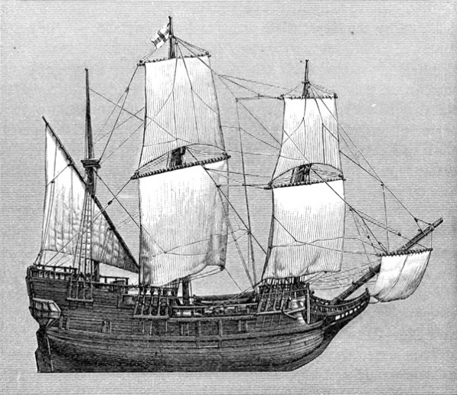
Today’s lesson about the Mayflower requires that you get into groups of three.
Learning Target #1- Students will be able to use sensory language to add vivid detail and description when writing a narrative paragraph about an event, person, place, or thing in American history . This understanding will make them a more effective writer.
Learning Target #2- Through literature that exposes the founding of America and defines Americans, students will understand the effort, sacrifice, brutality, dedication, desire, and determination it took to establish the United States. (This will be an ongoing target.)

Academic Vocabulary
Sensory language is the use of details from the five senses to add color and depth to writing. It helps readers visualize the scene a writer is setting.

Note: All work will be recorded in your journal. Label all sections by the task and number.

Task 1- (Picture Challenge)
- There are three pictures of an event. Each person in your group should select a picture to write about. This will be a timed write (5 minutes).
Each person needs to write a descriptive paragraph about the picture they have selected. Use vivid details to describe the scene in the picture. Pretend that your words are the picture. Use sensory language to effectively demonstrate what you can hear, and taste, and smell, and clearly see in the scene/picture you have chosen. Your reader will not have the picture, only your words, so use a lot of detail to describe the picture.
- Partner Share (Switch with someone who wrote about the same picture you wrote about and underline their best descriptive sentence.)

Task 2- (Predictions)
- Before you research or learn about a topic, it helps to assess what you know and what you can guess you are going to discover. Asking questions and making predictions makes us more focused as we research or learn about a topic.
- Predict the answers to these questions (5-7 minutes):
1. Who were the people on the Mayflower and why were they going to a new country?
2. How long was their journey?
3. What was their plan once they got there?
4. What was it like inside the boat?
- Watch the two videos at this link:
http://www.history.com/topics/mayflower/videos/deconstructing-history-mayflower
- Mayflower video
- Deconstructing the Mayflower video
Answer the following questions (5 minutes):
5. What surprised you and why?
6. What didn't surprise you and why?
- Whole group discussion about the videos and what was learned.

Task 3- (Mayflower Compact)
(See Handout- follow the directions)
- Read Silently (5 minutes)
- Record your responses in your journal. (5 min.)
- Small Group Discussion- Discuss your answers. (5 min.)
- Large Group Discussion- Structure, Word Choice, Content/Meaning

