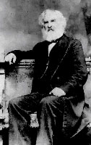
Biography of Henry Wadsworth Longfellow http://www.poemhunter.com/henry-wadsworth-longfellow/biography/

Henry Wadsworth was an American poet and educator whose works include "Paul Revere's Ride", The Song of Hiawatha, and Evangeline. He was also the first American to translate Dante Alighieri's The Divine Comedy and was one of the five Fireside Poets.
Longfellow was born on February 27, 1807, to Stephen Longfellow and Zilpah (Wadsworth) Longfellow in Portland, Maine. His father was a lawyer, and his maternal grandfather, Peleg Wadsworth, was a general in the American Revolutionary War and a Member of Congress. He was named after his mother's brother Henry Wadsworth, a Navy lieutenant who died only three years earlier at the Battle of Tripoli. Young Longfellow was the second of eight children.
Henry Wadsworth Longfellow was enrolled in a dame school at the age of three and by age six was enrolled at the private Portland Academy. In his years there, he earned a reputation as being very studious and became fluent in Latin. His mother encouraged his enthusiasm for reading and learning, introducing him to Robinson Crusoe and Don Quixote. He printed his first poem – a patriotic and historical four stanza poem called "The Battle of Lovell's Pond" – in the Portland Gazette on November 17, 1820. He was 13. He stayed at the Portland Academy until the age of fourteen. He spent much of his summers as a child at his grandfather Peleg's farm in the western Maine town of Hiram.
In the fall of 1822, the 15-year old Longfellow enrolled at Bowdoin College in Brunswick, Maine, alongside his brother Stephen. His grandfather was a founder of the college and his father was a trustee. There, Longfellow met Nathaniel Hawthorne, who would later become his lifelong friend. He joined the Peucinian Society, a group of students with Federalist leanings.
He pursued his literary goals by submitting poetry and prose to various newspapers and magazines, partly due to encouragement from a professor named Thomas Cogswell Upham. Between January 1824 and his graduation in 1825, he had published nearly 40 minor poems. About 24 of them appeared in the short-lived Boston periodical The United States Literary Gazette. When Longfellow graduated from Bowdoin, he was ranked fourth in the class, and had been elected to Phi Beta Kappa. He gave the student commencement address.
After graduating in 1825, he was offered a job as professor of modern languages at his alma mater. Instead, he began his tour of Europe in May 1826 aboard the ship Cadmus. His time abroad would last three years and cost his father $2,604.24. He traveled to France, Spain, Italy, Germany, back to France, then England before returning to the United States in mid-August 1829. While overseas, he learned French, Spanish, Portuguese, and German, mostly without formal instruction. While in Spain, Longfellow was saddened to learn his favorite sister, Elizabeth, had died of tuberculosis at the age of 20 that May while he was abroad.
On September 14, 1831, Longfellow married Mary Storer Potter, a childhood friend from Portland. The couple settled in Brunswick, though the two were not happy there. Longfellow published several nonfiction and fiction prose pieces inspired by Irving, including "The Indian Summer" and "The Bald Eagle" in 1833.
In December 1834, Longfellow received a letter from Josiah Quincy III, president of Harvard College, offering him the Smith Professorship of Modern Languages position with the stipulation that he spend a year or so abroad. There, he further studied German as well as Dutch, Danish, Swedish, Finnish, and Icelandic. In October 1835, during the trip, his wife Mary had a miscarriage about six months into her pregnancy. She did not recover and died after several weeks of illness at the age of 22 on November 29, 1835. Longfellow had her body embalmed immediately and placed into a lead coffin inside an oak coffin which was then shipped to Mount Auburn Cemetery near Boston. He was deeply saddened by her death, writing "One thought occupies me night and day... She is dead—She is dead! All day I am weary and sad". Three years later, he was inspired to write the poem "Footsteps of Angels" about her. Several years later, he wrote the poem "Mezzo Cammin" expressed his personal struggles in his middle years.
When he returned to the United States in 1836, Longfellow took up the professorship at Harvard. He was required to live in Cambridge to be close to the campus and rented rooms at the Craigie House in the spring of 1837, now preserved as the Longfellow House–Washington's Headquarters National Historic Site. The home, built in 1759, had once been the headquarters of George Washington during the Siege of Boston beginning in July 1775. Previous boarders also included Jared Sparks, Edward Everett, and Joseph Emerson Worcester. Longfellow began publishing his poetry, including the collection Voices of the Night in 1839. The bulk of Voices of the Night, Longfellow's debut book of poetry, was translations though he also included nine original poems and seven poems he had written as a teenager. Ballads and Other Poems was published shortly thereafter in 1841 and included "The Village Blacksmith" and "The Wreck of the Hesperus", which were instantly popular. Longfellow also became part of the local social scene, creating a group of friends who called themselves the Five of Clubs.
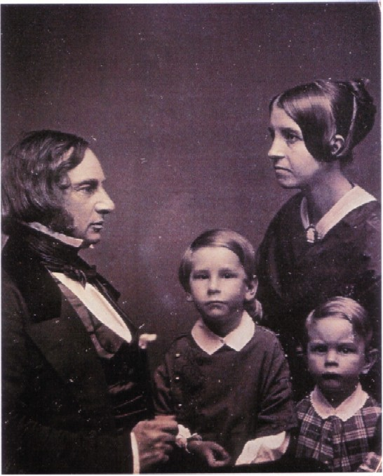
Longfellow began courting Frances "Fanny" Appleton, the daughter of a wealthy Boston industrialist, Nathan Appleton and sister of Thomas Gold Appleton. At first, she was not interested but Longfellow was determined. On May 10, 1843, after seven years, Longfellow received a letter from Fanny Appleton agreeing to marry him and, too restless to take a carriage, walked 90 minutes to meet her at her house. They were married shortly thereafter. Nathan Appleton bought the Craigie House as a wedding present to the pair. Longfellow would live there for the remainder of his life. His love for Fanny is evident in the following lines from Longfellow's only love poem, the sonnet "The Evening Star", which he wrote in October 1845: "O my beloved, my sweet Hesperus! My morning and my evening star of love!" He once attended a ball without her and noted, "The lights seemed dimmer, the music sadder, the flowers fewer, and the women less fair."
He and Fanny had six children: Charles Appleton (1844–1893), Ernest Wadsworth (1845–1921), Fanny (1847–1848), Alice Mary (1850–1928), Edith (1853–1915), and Anne Allegra (1855–1934). Their second-youngest daughter, Edith, married Richard Henry Dana III, son of the popular writer Richard Henry Dana, Jr., author of Two Years Before the Mast. When the younger Fanny was born on April 7, 1847, Dr. Nathan Cooley Keep administered ether as the first obstetric anesthetic in the United States to Fanny Longfellow. A few months later, on November 1, 1847, the poem "Evangeline" was published for the first time. His literary income was increasing considerably: in 1840, he had made $219 from his work but the year 1850 brought him $1,900.
On June 14, 1853, Longfellow held a farewell dinner party at his Cambridge home for his friend Nathaniel Hawthorne, who was preparing to move overseas. Shortly thereafter in 1854, Longfellow retired from Harvard, devoting himself entirely to writing. He was awarded an honorary doctorate of Laws from Harvard in 1859.
Death of Frances
On July 9, 1861, a hot day, Fanny was putting locks of her children's hair into an envelope and attempting to seal it with hot sealing wax while Longfellow took a nap. Her dress suddenly caught fire, though it is unclear exactly how; it may have been burning wax or a lighted candle which fell on her dress. Longfellow, awakened from his nap, rushed to help her and threw a rug over her, though it was too small. He stifled the flames with his body as best he could, but she was already badly burned. Over a half a century later, Longfellow's youngest daughter Annie explained the story differently, claiming that there was no candle or wax but that the fire started from a self-lighting match that had fallen on the floor. In both versions of the story, however, Fanny was taken to her room to recover and a doctor was called. She was in and out of consciousness throughout the night and was administered ether. The next morning, July 10, 1861, she died shortly after 10 o'clock after requesting a cup of coffee. Longfellow, in trying to save her, had burned himself badly enough that he was unable to attend her funeral. His facial injuries caused him to stop shaving, thereafter wearing the beard which has become his trademark.
Devastated by her death, he never fully recovered and occasionally resorted to laudanum and ether to deal with it. He worried he would go insane and begged "not to be sent to an asylum" and noted that he was "inwardly bleeding to death". He expressed his grief in the
sonnet "The Cross of Snow" (1879), which he wrote eighteen years later to commemorate her death:
Later Life and Death
Longfellow spent several years translating Dante Alighieri's Divine Comedy. By 1868, Longfellow's annual income was over $48,000. In 1874, Samuel Cutler Ward helped him sell the poem "The Hanging of the Crane" to the New York Ledger for $3,000; it was the highest price ever paid for a poem. During the 1860s, Longfellow supported abolitionism and especially hoped for reconciliation between the northern and southern states after the American Civil War. He wrote in his journal in 1878: "I have only one desire; and that is for harmony, and a frank and honest understanding between North and South". In March 1882, Longfellow went to bed with severe stomach pain. He endured the pain for several days with the help of opium before he died surrounded by family on Friday, March 24, 1882. He had been suffering from peritonitis. At the time of his death, his estate was worth an estimated $356,320. He is buried with both of his wives at Mount Auburn Cemetery in Cambridge, Massachusetts. His last few years were spent translating the poetry of Michelangelo; though Longfellow never considered it complete enough to be published during his lifetime, a posthumous edition was collected in 1883. Scholars generally regard the work as autobiographical, reflecting the translator as an aging artist facing his impending death.
Also known as one of the Fireside Poets, Longfellow was the most popular poet of his day and is generally regarded as the most distinguished poet the country had produced. As a friend once wrote to him, "no other poet was so fully recognized in his lifetime". Many of his works helped shape the American character and its legacy, particularly with the poem "Paul Revere's Ride". He was such an admired figure in the United States during his life that his 70th birthday in 1877 took on the air of a national holiday, with parades, speeches, and the reading of his poetry.
Over the years, Longfellow's personality has become part of his reputation. He has been presented as a gentle, placid, poetic soul: an image perpetuated by his brother Samuel Longfellow, who wrote an early biography which specifically emphasized these points. As James Russell Lowell said, Longfellow had an "absolute sweetness, simplicity, and modesty". At Longfellow's funeral, his friend Ralph Waldo Emerson called him "a sweet and beautiful soul". In reality, Longfellow's life was much more difficult than was assumed. He suffered from neuralgia, which caused him constant pain, and he also had poor eyesight. He wrote to friend Charles Sumner: "I do not believe anyone can be perfectly well, who has a brain and a heart".

