http://ic.galegroup.com/ic/uhic/ReferenceDetailsPage/ReferenceDetailsWindow?zid=4fb813ea97735d41ab725ceb78e51a34&action=2&catId=&documentId=GALE%7CCX3426600013&userGroupName=tlc199095657&jsid=1787a11652f6ef409d1ae60cea2a7112

Salem Town and Salem Village
Witchcraft in America, 2001
From U.S. History in Context

The first three Salem "witches"

Tituba, Sarah Good, and Sarah Osborne
On February 29, 1692, Salem villagers Thomas and Edward Putnam, Joseph Hutchinson, and Thomas Preston together swore official complaints in court against Tituba, Sarah Good, and Sarah Osborne. These men were all supporters of Samuel Parris, who said that Betty and Abigail had identified the women as witches. Besides Tituba, thirty-nine-year-old Sarah Good was the first person to be accused. According to The Salem Witch TrialsAnn Putnam, Jr. swore to Magistrates John Hathorne and Johnathan Corwin that she been plagued by an "apparition of Sarah Good which did torture [her] most grievously." She claimed the apparition then pinched and pricked her for days, while urging her to become a witch. Putnam also said she had witnessed Good doing the same things to other girls, who all confirmed her charges for the magistrates. The three accused witches were taken to jail on March 1 and examined for marks by the magistrates. On this fateful day, Tituba readily confessed to the crime of witchcraft and proclaimed the guilt of Good and Osborne as well. Perhaps she thought she stood a better chance of being released if she admitted to a relationship with Satan and accused the other women of evil acts.

Sarah Good's unlucky past
Sarah Good was pregnant, widowed, and poor, with a four-year-old child at the time charges of witchcraft were brought against her. She had had an extremely difficult life. In 1672, when she was a teenager, her father, John Solart, committed suicide and brought scorn and suspicion on his family. The Solarts were living in nearby Wendham village, and they were one of many families involved in disputes over land rights that had caused divisions between Salem Town and Salem Village. Solart's widow remarried, but she refused to share most of his estate with their seven children, leaving them to fend for themselves. Sarah managed to get a few acres of her mother's property near Salem Village, then married Daniel Poole, an indentured servant (one who signs a contract to work for an employer for a specified length of time). Poole died almost immediately, leaving Sarah deeply in debt. When she married William Good, Poole's creditors seized their land as payment for Poole's debts. Now homeless, the Goods begged for food and shelter. Sarah also began to age beyond her years because her life had been so stressful: village records reveal that when she was in her late thirties she appeared to be around seventy years old. Sarah Good's present circumstances and family history made her a prime candidate for accusations of witchcraft. Once she was charged, she could not refute the "spectral evidence"—proof of association with evil spirits—that was the primary weapon against her. Court records show that the magistrates bullied Good and accepted accusations made by Betty Parris and Abigail Williams, even though there was a lack of physical evidence.

Sarah Osborne falls prey to suspicion
When Sarah Good was first examined by the magistrates, she denied the charges against her. Moreover, she announced that Sarah Osborne was responsible for the fits experienced by Betty and Abigail, thus confirming the girls' accusations. Osborne was a frail sixty-nine-year-old invalid who also came under suspicion because of land disputes. Her first husband, Robert Prince, had been a successful and active citizen who owned over 150 acres of land along a controversial dividing line between Salem Village and the adjacent (next) town of Topsfield. When Prince died, Sarah married their indentured servant John Osborne and tried to change the terms of her dead husband's will. Prince had specified that his two
Bridget Bishop
http://law2.umkc.edu/faculty/projects/ftrials/salem/sal_bbis.htm
In addition to her somewhat outrageous (by Puritan standards) lifestyle, the fact that Bishop "was in the habit of dressing more artistically than women of the village" also contributed in large part to her conviction and execution. She was described as wearing, "a black cap, and a black hat, and a red paragon bodice bordered and looped with different colors." This was a showy costume for the times. Aside from encouraging rumors and social disdain, this "showy costume" was used as evidence against her at her trial for witchcraft. In his deposition, Shattuck, the town dyer mentions, as corroborative proof of Bishop being a witch, that she used to bring to his dye house "sundry pieces of lace" of shapes and dimensions entirely outside his conceptions of what would be needed in the wardrobe of a plain and honest woman. Fashionable apparel was regarded by some as a "snare and sign of the devil."
On April 18, 1692, when a warrant was issued for Bishop's arrest for witchcraft, she was no stranger to the courthouse. In 1680 she had been charged (but cleared) of witchcraft, and on other occasions she had ended up in the courthouse for violent public quarreling with her husband. Bishop had never seen or met any of her accusers until her questioning. While several of the afflicted girls cried out and writhed in the supposed pain she was causing them, John Hathorn and Jonathan Corwin questioned her, although there was little doubt in either of their minds as to her guilt:
Q: Bishop, what do you say? You stand here charged with sundry acts of witchcraft by you done or committed upon the bodies of Mercy Lewis and Ann Putman and others.
A: I am innocent, I know nothing of it, I have done no witchcraft .... I am as innocent as the child unborn. ....
Q: Goody Bishop, what contact have you made with the Devil?
A: I have made no contact with the Devil. I have never seen him before in my life.

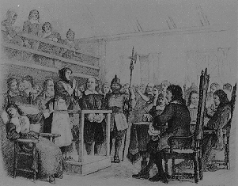

O Christian Martyr Who for Truth could die
When all about thee Owned the hideous lie!
The world, redeemed from superstition's sway,
Is breathing freer for thy sake today.
--Words written by John Greenleaf Whittier and
inscribed on a monument marking the grave of
Rebecca Nurse.

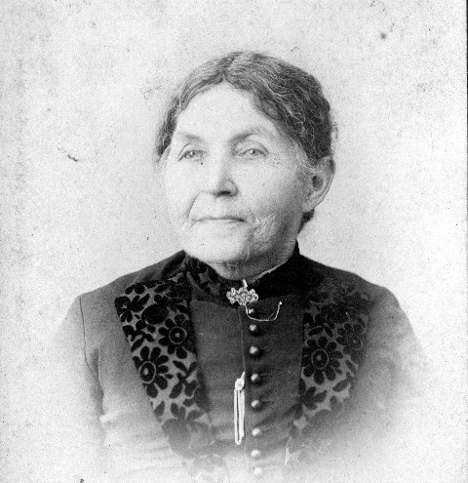
Sarah Osborn
