EXAMINATION OF TITUBA (Primary Source)
Tituba the Ind'n Woem'ns Examn March. 1. 1691/2 [March 1,1692]
Why doe you hurt these poor Children? whatt harme have thay done ont you?
Tituba: thay doe noe harme to me I noe hurt them att all.
Why have you done itt?
T:I have done nothing; I Can‘t tell when the Devill works
what doe the Devill tell you that he hurts them?
T:noe he tells me nothing
doe you never see Something appeare in Some shape?
T:noe never See any thing
what familiarity have you w'th the devill, or w't is itt if you Converse q'th all? Tell the truth whoe itt is that hurts them
T: the Devill for ought I know
w't appearanc or how dothe he appeare when the hurts them, w'th w't shape or what is he like that hurts them
T: like a man I think yesterday I being in the Lentoe Chamber I saw a thing like a man, that tould me Searve him & I tould him noe I would nott doe Such thing. [Recorder's note: she charges Goody Osborne & Sarah Good as those that hurt the Childrenwould they have had you hurt the Children the Last Night
T: yes, butt I was Sorry & I sayd, I would doe Soe noe more, but tould I would feare God.
did you ever goe w'th these woemen?
T: they are very strong & pull me & make me goe w'th them
how did youo goe? What doe you Ride upon?
T: I Rid upon a stick or poale & Good & Osburne behind me we Ride taking hold of one another don't know how we goe for I Saw noe trees nor path, but was presently there. when wee were up
EXAMINATION OF TITUBA (Primary Source)
Tituba the Ind'n Woem'ns Examn March. 1. 1691/2 [March 1,1692]
Why doe you hurt these poor Children? whatt harme have thay done ont you?
Tituba: thay doe noe harme to me I noe hurt them att all.
Why have you done itt?
T:I have done nothing; I Can‘t tell when the Devill works
what doe the Devill tell you that he hurts them?
T:noe he tells me nothing
doe you never see Something appeare in Some shape?
T:noe never See any thing
what familiarity have you w'th the devill, or w't is itt if you Converse q'th all? Tell the truth whoe itt is that hurts them
T: the Devill for ought I know
w't appearanc or how dothe he appeare when the hurts them, w'th w't shape or what is he like that hurts them
T: like a man I think yesterday I being in the Lentoe Chamber I saw a thing like a man, that tould me Searve him & I tould him noe I would nott doe Such thing. [Recorder's note: she charges Goody Osborne & Sarah Good as those that hurt the Childrenwould they have had you hurt the Children the Last Night
T: yes, butt I was Sorry & I sayd, I would doe Soe noe more, but tould I would feare God.
did you ever goe w'th these woemen?
T: they are very strong & pull me & make me goe w'th them
how did youo goe? What doe you Ride upon?
T: I Rid upon a stick or poale & Good & Osburne behind me we Ride taking hold of one another don't know how we goe for I Saw noe trees nor path, but was presently there. when wee were up

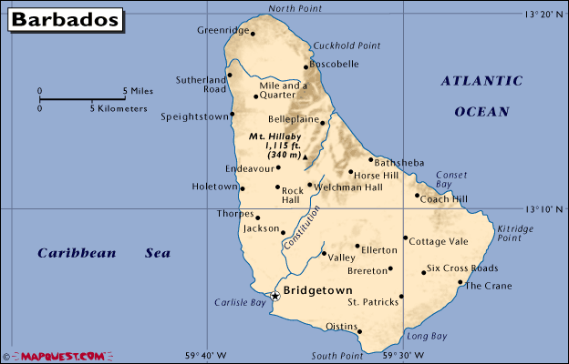
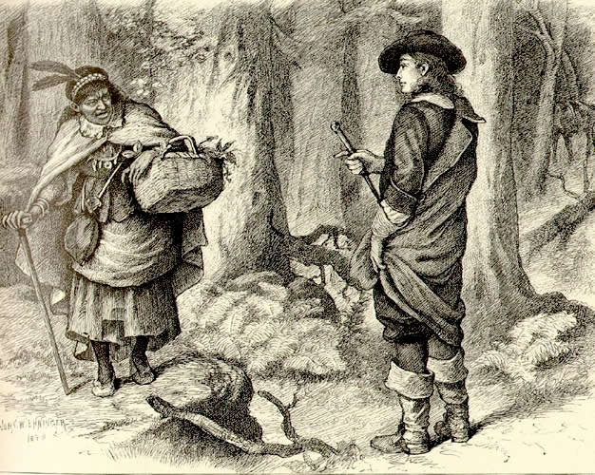
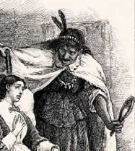
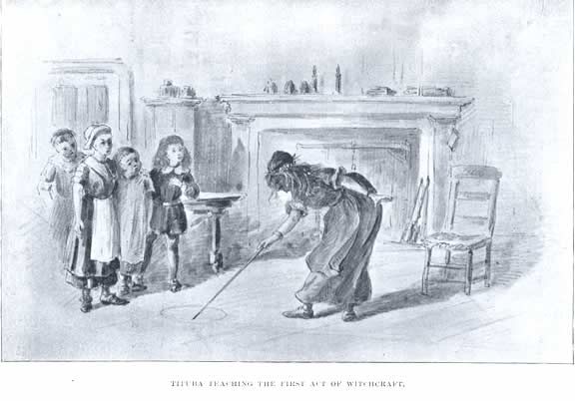

Tituba Biography (2012) http://www.historyrocket.com/Biography/Tituba-Biography.html
Tituba was an Indian woman and not as commonly believed a Negro slave. She was one of the first three people accused of practicing witchcraft during the Salem witch trials of 1692 in Salem village, Massachusetts. Tituba was originally from an Arawak village in South America. As a child she was captured, taken to Barbados and sold into slavery.
Tituba was purchased by Reverend Samuel Parris, or given to settle debt, while Parris was a merchant in Barbados. Since Parris was unmarried it was rumored that she may have served as his concubine. Tituba helped maintain the Parris household on day-to-day basis. When Parris moved to Boston in 1680, Tituba got married to another Indian slave named John. John and Tituba then moved to Salem.
It was in Salem where Tituba was first accused of practicing witchcraft and eventually confessed (even though she did not believe she had). Tituba was the third person accused by Parris of witchcraft. She was, however, the first person to confess witchcraft in Salem village. She first denied that she had anything to do with witchcraft, but she finally confessed of having been spoken to by the Devil. It is likely that she did this to avoid further punishment. Tituba avoided the ordeal of going to trial, joined other afflicted girls in providing key evidence against the accused witches. When public sentiment towards the accuser and the trials began to change, Tituba recanted her confession. This further enraged Parris who refused to pay the jailer’s fee as a result Tituba spent thirteen months in jail. Then an unknown person paid seven pounds and freed her. It is unknown what happened to her after she began her life with the new owner.

Tituba Biography (2012) http://www.historyrocket.com/Biography/Tituba-Biography.html
Tituba was an Indian woman and not as commonly believed a Negro slave. She was one of the first three people accused of practicing witchcraft during the Salem witch trials of 1692 in Salem village, Massachusetts. Tituba was originally from an Arawak village in South America. As a child she was captured, taken to Barbados and sold into slavery.
Tituba was purchased by Reverend Samuel Parris, or given to settle debt, while Parris was a merchant in Barbados. Since Parris was unmarried it was rumored that she may have served as his concubine. Tituba helped maintain the Parris household on day-to-day basis. When Parris moved to Boston in 1680, Tituba got married to another Indian slave named John. John and Tituba then moved to Salem.
It was in Salem where Tituba was first accused of practicing witchcraft and eventually confessed (even though she did not believe she had). Tituba was the third person accused by Parris of witchcraft. She was, however, the first person to confess witchcraft in Salem village. She first denied that she had anything to do with witchcraft, but she finally confessed of having been spoken to by the Devil. It is likely that she did this to avoid further punishment. Tituba avoided the ordeal of going to trial, joined other afflicted girls in providing key evidence against the accused witches. When public sentiment towards the accuser and the trials began to change, Tituba recanted her confession. This further enraged Parris who refused to pay the jailer’s fee as a result Tituba spent thirteen months in jail. Then an unknown person paid seven pounds and freed her. It is unknown what happened to her after she began her life with the new owner.
Tituba Biography (2012) http://www.historyrocket.com/Biography/Tituba-Biography.html
Tituba was an Indian woman and not as commonly believed a Negro slave. She was one of the first three people accused of practicing witchcraft during the Salem witch trials of 1692 in Salem village, Massachusetts. Tituba was originally from an Arawak village in South America. As a child she was captured, taken to Barbados and sold into slavery.
Tituba was purchased by Reverend Samuel Parris, or given to settle debt, while Parris was a merchant in Barbados. Since Parris was unmarried it was rumored that she may have served as his concubine. Tituba helped maintain the Parris household on day-to-day basis. When Parris moved to Boston in 1680, Tituba got married to another Indian slave named John. John and Tituba then moved to Salem.
It was in Salem where Tituba was first accused of practicing witchcraft and eventually confessed (even though she did not believe she had). Tituba was the third person accused by Parris of witchcraft. She was, however, the first person to confess witchcraft in Salem village. She first denied that she had anything to do with witchcraft, but she finally confessed of having been spoken to by the Devil. It is likely that she did this to avoid further punishment. Tituba avoided the ordeal of going to trial, joined other afflicted girls in providing key evidence against the accused witches. When public sentiment towards the accuser and the trials began to change, Tituba recanted her confession. This further enraged Parris who refused to pay the jailer’s fee as a result Tituba spent thirteen months in jail. Then an unknown person paid seven pounds and freed her. It is unknown what happened to her after she began her life with the new owner.
Tituba Biography (2012) http://www.historyrocket.com/Biography/Tituba-Biography.html
Tituba was an Indian woman and not as commonly believed a Negro slave. She was one of the first three people accused of practicing witchcraft during the Salem witch trials of 1692 in Salem village, Massachusetts. Tituba was originally from an Arawak village in South America. As a child she was captured, taken to Barbados and sold into slavery.
Tituba was purchased by Reverend Samuel Parris, or given to settle debt, while Parris was a merchant in Barbados. Since Parris was unmarried it was rumored that she may have served as his concubine. Tituba helped maintain the Parris household on day-to-day basis. When Parris moved to Boston in 1680, Tituba got married to another Indian slave named John. John and Tituba then moved to Salem.
It was in Salem where Tituba was first accused of practicing witchcraft and eventually confessed (even though she did not believe she had). Tituba was the third person accused by Parris of witchcraft. She was, however, the first person to confess witchcraft in Salem village. She first denied that she had anything to do with witchcraft, but she finally confessed of having been spoken to by the Devil. It is likely that she did this to avoid further punishment. Tituba avoided the ordeal of going to trial, joined other afflicted girls in providing key evidence against the accused witches. When public sentiment towards the accuser and the trials began to change, Tituba recanted her confession. This further enraged Parris who refused to pay the jailer’s fee as a result Tituba spent thirteen months in jail. Then an unknown person paid seven pounds and freed her. It is unknown what happened to her after she began her life with the new owner.

