To John Cotton DI/AAS August 5, 1692
August 5, 1692
Reverend Sir,
Our good God is working of miracles. Five witches were lately executed, impudently demanding of God a miraculous vindication of their innocency. Immediately upon this, our God miraculously sent in five Andover witches, who made a most ample, surprising, amazing confession of all their villainies, and declared the five newly executed to have been of their company, discovering many more, but all agreeing in Burroughs being their ringleader, who, I suppose, this day receives his trial at Salem, whither a vast concourse of people is gone, my father this morning among the rest. Since those, there have come in other confessors; yea, they come in daily. About this prodigious matter my soul has been refreshed with some little short of miraculous answers of prayer, which are not to be written; but they comfort me with a prospect of a hopeful issue.

To John Cotton DI/AAS August 5, 1692
August 5, 1692
Reverend Sir,
Our good God is working of miracles. Five witches were lately executed, impudently demanding of God a miraculous vindication of their innocency. Immediately upon this, our God miraculously sent in five Andover witches, who made a most ample, surprising, amazing confession of all their villainies, and declared the five newly executed to have been of their company, discovering many more, but all agreeing in Burroughs being their ringleader, who, I suppose, this day receives his trial at Salem, whither a vast concourse of people is gone, my father this morning among the rest. Since those, there have come in other confessors; yea, they come in daily. About this prodigious matter my soul has been refreshed with some little short of miraculous answers of prayer, which are not to be written; but they comfort me with a prospect of a hopeful issue.

To John Cotton DI/AAS August 5, 1692
August 5, 1692
Reverend Sir,
Our good God is working of miracles. Five witches were lately executed, impudently demanding of God a miraculous vindication of their innocency. Immediately upon this, our God miraculously sent in five Andover witches, who made a most ample, surprising, amazing confession of all their villainies, and declared the five newly executed to have been of their company, discovering many more, but all agreeing in Burroughs being their ringleader, who, I suppose, this day receives his trial at Salem, whither a vast concourse of people is gone, my father this morning among the rest. Since those, there have come in other confessors; yea, they come in daily. About this prodigious matter my soul has been refreshed with some little short of miraculous answers of prayer, which are not to be written; but they comfort me with a prospect of a hopeful issue.

To John Cotton DI/AAS August 5, 1692
August 5, 1692
Reverend Sir,
Our good God is working of miracles. Five witches were lately executed, impudently demanding of God a miraculous vindication of their innocency. Immediately upon this, our God miraculously sent in five Andover witches, who made a most ample, surprising, amazing confession of all their villainies, and declared the five newly executed to have been of their company, discovering many more, but all agreeing in Burroughs being their ringleader, who, I suppose, this day receives his trial at Salem, whither a vast concourse of people is gone, my father this morning among the rest. Since those, there have come in other confessors; yea, they come in daily. About this prodigious matter my soul has been refreshed with some little short of miraculous answers of prayer, which are not to be written; but they comfort me with a prospect of a hopeful issue.

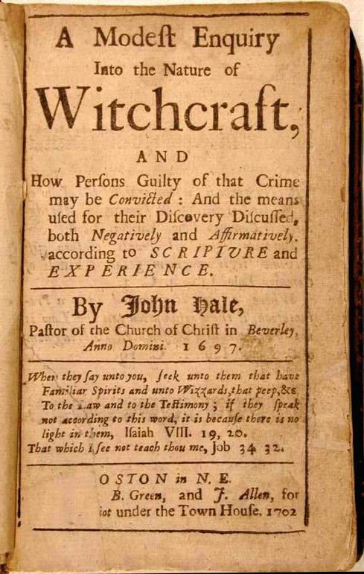
Samuel Parris
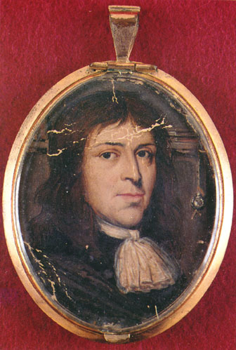
1 Samuel 15:23 (KJV) "For rebellion is as the sin of witchcraft..."
Exodus 22:18 (KJV) "Thou shalt not suffer a witch to live."
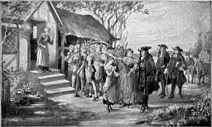
Lord’s Prayer Test
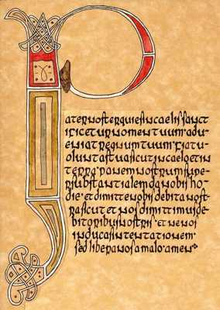
This was a literal test of faith. The accused would be made to recite the “Lord’s Prayer” without error – this included any stumbling, stammering, or outright spasming. As elocution is a painstaking art, it seems that any average human would slip up, but under “God’s eyes” (as well as whoever else sees themselves fit to judge) mistakes are unacceptable. As far as fits go, try forcing someone who may be mentally-retarded or hysterical (medically-speaking) or hallucinating from LSD-fungus-covered rye bread (another suspect of these ubiquitous “fits”) to read from the bible with absolute level-headedness.
There was disagreement about the choice of Samuel Parris as Salem Village's first ordained minister. On June 18, 1689, the villagers agreed to hire Parris for ₤66 annually, "one third part in money and the other two third parts in provisions" and use of the parsonage.^{[18]} On October 10, 1689, however, they voted to grant him the deed to the parsonage and two acres (0.8 hectares) of land,^{[19]} despite a vote by the inhabitants in 1681 stating, "it shall not be lawful for the inhabitants of this village to convey the houses or lands or any other concerns belonging to the Ministry to any particular persons or person: not for any cause by vote or other ways".^{[20]} Though the prior ministers' fates and the level of contention in the village were valid reasons for caution in accepting the position, Reverend Parris only increased the village's divisions by delaying accepting his position in Salem Village. Neither had he any gift for settling his new parishioners' disputes: by deliberately seeking out "iniquitous behavior" in his congregation and making church members in good standing suffer public penance for small infractions, he made a significant contribution toward the tension within the village, and the bickering in the village continued to grow unabated. In this atmosphere, serious conflict may have been inevitable.^{[21]}

http://www.salemweb.com/memorial/chronology.shtml
A Chronology of Events-
January 20
Nine-year-old Elizabeth Parris and eleven-year-old Abigail Williams began to exhibit strange behavior, such as blasphemous screaming, convulsive seizures, trance-like states and mysterious spells. Within a short time, several other Salem girls began to demonstrate similar behavior.
Mid-February
Unable to determine any physical cause for the symptoms and dreadful behavior, physicians concluded that the girls were under the influence of Satan.
Late February
Prayer services and community fasting were conducted by Reverend Samuel Parris in hopes of relieving the evil forces that plagued them. In an effort to expose the "witches", John Indian baked a witch cake made with rye meal and the afflicted girls' urine. This counter-magic was meant to reveal the identities of the "witches" to the afflicted girls.Pressured to identify the source of their affliction, the girls named three women, including Tituba, Parris' Carib Indian slave, as witches. On February 29, warrants were issued for the arrests of Tituba, Sarah Good and Sarah Osborne. Although Osborne and Good maintained innocence, Tituba confessed to seeing the devil who appeared to her "sometimes like a hog and sometimes like a great dog". What's more, Tituba testified that there was a conspiracy of witches at work in Salem.
March 1
Magistrates John Hathorne and Jonathan Corwin examined Tituba, Sarah Good, and Sarah Osborne in the meeting house in Salem Village. Tituba confessed to practicing witchcraft. Over the next weeks, other townspeople came forward and testified that they, too, had been harmed by or had seen strange apparitions of some of the community members. As the witch hunt continued, accusations were made against many different people. Frequently denounced were women whose behavior or economic circumstances were somehow disturbing to the social order and conventions of the time. Some of the accused had previous records of criminal activity, including witchcraft, but others were faithful churchgoers and people of high standing in the community.
March 12
Martha Corey is accused of witchcraft.
March 19
Rebecca Nurse was denounced as a witch.
March 21
Martha Corey was examined before Magistrates Hathorne and Corwin.
March 24
Rebecca Nurse was examined before Magistrates Hathorne and Corwin.
March 28
Elizabeth Proctor was denounced as a witch.
April 3
Sarah Cloyce, Rebecca Nurse's sister, was accused of witchcraft.
April 11
Elizabeth Proctor and Sarah Cloyce were examined before Hathorne, Corwin, Deputy Governor Thomas Danforth, and Captain Samuel Sewall. During this examination, John Proctor was also accused and imprisoned.
April 19
Abigail Hobbs, Bridget Bishop, Giles Corey, and Mary Warren were examined. Only Abigail Hobbs confessed.
William Hobbs
"I can deny it to my dying day."

