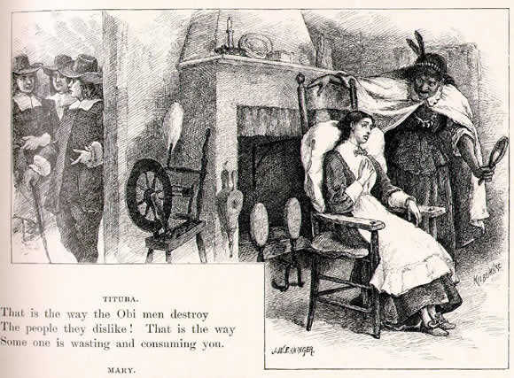
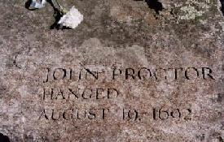
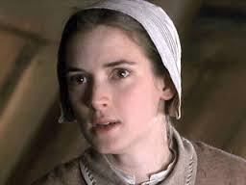
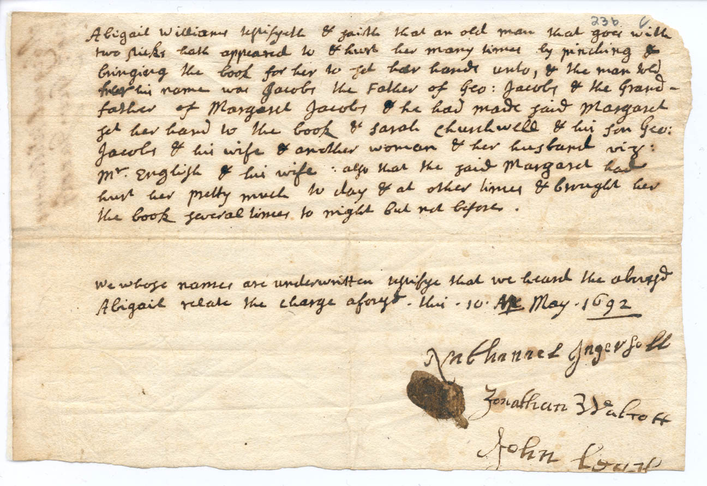

From The Salem Witchcraft Trials: A Legal History, by Peter Charles Hoffer
Chapter 9, The Scoffers, pages 108-110:
John Proctor and George Burroughs were brought to trial on charges of witchcraft on August 2, 1692. Despite their spirited defense, they were condemned to die. The sentence was carried out on August 19, both men insisting to the end that the court was unfair to them.
The Puritans of eastern Massachusetts were no more authoritarian in their views or ways than any comparable group of English men and women. New England ministers and magistrates demanded the respect and obedience that any English pastor or justice of the peace could reasonably expect at home. But in the midst of the witchcraft crisis, challenges to authority took on more sinister shape. Critics of church and state cracked the wall of piety, allowing the sinuous Evil One to enter God’s land. Indeed, cynicism and criticism were seen by some as evidence that a scoffer had already made a pact with the Devil. Tavern keeper John Proctor and minister George Burroughs were two of these scoffers, and they paid for their attitude with their lives.

History of Massachusetts

http://historyofmassachusetts.org/betty-parris-first-afflicted-girl-of-the-salem-witch-trials/

Betty Parris: First Afflicted Girl of the Salem Witch Trials
Elizabeth “Betty” Parris was the first afflicted girl and one of the chief accusers during the Salem Witch Trials of 1692.Born in Boston on November 28 of 1682, Betty moved to Salem with her family and slave Tituba in November of 1689 when her father, Samuel Parris was appointed the new minister of Salem Village.In the winter of 1691-1692, Betty, her orphaned cousin Abigail Williams and the other afflicted girls dabbled in fortune-telling techniques, such as a “venus glass” in which the girls dropped an egg white into a glass of water so that a shape or symbol appeared, in an attempt to learn more about their future husbands and social status. Although some sources indicate that it was Tituba who taught the girls these fortune-telling techniques, there is no mention of this in the court records and no evidence that she was involved. According to the book “A Modest Enquiry Into the Nature of Witchcraft” by local minister, Reverend John Hale, on one of these occasions the girls became terrified when they saw the shape of a coffin in the glass.

John Proctor: First Male Accused Witch
Posted on October 27, 2011 by Rebecca Beatrice Brooks
Although Miller depicts Abigail Williams and John Proctor as lovers, it is unlikely this occurred since Proctor was 60 years old and Williams was 11 at the time of the hysteria and there is no evidence that they even knew each other before the trial. Nonetheless, in an essay Miller wrote for the New Yorker in 1996, he stated that he fully believed John Proctor had a relationship with Williams and based his entire play on the idea after he read court records indicating Williams tried to strike Elizabeth Proctor during her trial but could not bring herself to do it and instead lightly touched her hood, crying out that her touch burned:
“In this remarkably observed gesture of a troubled young girl, I believed, a play became possible. Elizabeth Proctor had been the orphaned Abigail’s mistress, and they had lived together in the same small house until Elizabeth fired the girl. By this time, I was sure, John Proctor had bedded Abigail, who had to be dismissed most likely to appease Elizabeth. There was bad blood between the two women now. That Abigail started, in effect, to condemn Elizabeth to death with her touch, then stopped her hand, then went through with it, was quite suddenly the human center of all this turmoil.”
Sources: The Crucible; Arthur Miller; 1953
The New Yorker; Why I Wrote the Crucible; Arthur Miller; October 21 1996: http://www.newyorker.com/archive/1996/10/21/1996_10_21_158_TNY_CARDS_000373902

Elizabeth Parris

http://salem.lib.virginia.edu/people?group.num=all&mbio.num=mb11
At nine years old, Elizabeth Parris, daughter of Salem Village minister Rev. Samuel Parris, played a key role in the beginnings of the witchcraft trials. Curious to know her future marital status , Elizabeth, together with her cousin Abigail Williams, cautiously experimented with fortune telling. Her behavior led to the first three accusations of witches. Trying to shield the involvement of his immediate family, the Rev. Samuel Parris, took Abigail from home and placed her in the home of Stephen Sewall in Salem, where she eventually recovered. She could not have predicted that these innocent attempts at predicting the future would lead to the largest and most deadly witch-hunt in American history.

