Salem Witchcraft: The Events and Causes of the Salem Witch Trials
By Tim Sutter © 2000-2003 http://www.salemwitchtrials.com/salemwitchcraft.html
Salem Politics
Salem Village had a very colorful history before the famous witch trials. It was not exactly known as a bastion of tranquillity in New England. The main reason was its 600 plus residents were divided into two main parts: those who wanted to separate from Salem Town, and those who did not. The residents who wanted to separate from Salem Town were farming families located in the western part of Salem Village. Those who wanted to remain a part of Salem Town were typically located on the eastern side of Salem Village--closest to Salem Town. The residents who wished to remain a part of Salem Town were economically tied to its thriving, rich harbors.
Many of the Salem Village farming families believed that Salem Town’s thriving economy made it too individualistic. This individualism was in opposition to the communal nature that Puritanism mandated. Thus, they were out of touch with the rest of Salem Village. One particularly large farming family who felt that Salem Town was out of touch with the rest of Salem Village was the Putnams.
The Putnams were the leaders of the separatist group primarily because they owned the most farmland in Salem Village. They hoped to solidify a separation from Salem Town by establishing a congregation unique from it. So in 1689, a congregation was formed under the Rev. Samuel Parris and began worshipping in the Salem Village Meetinghouse. However, the congregation only represented a select group since over half of its members were Putnams. If this action did not further strain already weakened relations between the two factions, the events concerning Parris’ contract did.
Contracts for ministers during this period often provided them with a modest salary, use of a house, and free firewood. Parris received this and much more. He not only got a modest salary and free firewood, but the title and deed to the parsonage and its surrounding land. Needless to say, this was a very uncommon perk to be included in a minister’s contract during this time. This perk especially angered the residents who wanted to remain a part of Salem Town. The Salem Town supporters showed their opposition by refusing to worship at the Meetinghouse and withholding their local taxes. This latter action was of important consequence because the local taxes helped pay the minister’s salary and provided his firewood.
In October of 1691 a new Salem Village Committee was elected that was comprised mostly of Parris’ opponents. This new committee refused to assess local taxes that would pay Parris’ salary, and also challenged the legality of his ownership of the ministry-house and property. These actions by the new committee caused Parris and his family to rely solely on voluntary contributions for sustenance. The Putnams were now worried of losing Parris and the soughted independence from Salem Town the congregation would help bring, and Parris was concerned about his job and providing for his family.

Revenge in the Salem Witchcraft Hysteria: The Putnam Family and George Burroughs
Anastasia Karson http://www.loyno.edu/~history/journal/1998-9/Karson.htm
When Burroughs returned to Salem to settle the issue of the owed money, he learned that John Putnam had issued the warrant for his arrest. John Putnam recited to the court debts that seemed extraordinary. Nathaniel Ingersoll, a cousin of Putnam, rose in the defense of Burroughs, saying the debts owed Putnam by Burroughs were none. It was common knowledge that the village owed Burroughs money for the services he rendered.
"Their most prominent members were men whose names were to appear again and again on the complaints to the magistrates that led to witchcraft arrests: Thomas Putnam, John Putnam Junior, Thomas’s brother-in-law Jonathan Walcott, and Walcott’s uncle, Nathaniel Ingersoll."<17> The Putnam brothers had a habit of working together "in an aggressive but underhanded manner to take down an enemy."<19>

Putnam Family
http://www.legendsofamerica.com/ma-putnam3.html#John Putnam, Sr.
This contempt in the Putnam family forces the question regarding the validity of the charges alleged against those who were enemies of the Putnam family. The accusation and arrest of many innocent people could have emerged from jealousy and resentment found in this powerful family, known as "the chief prosecutors in this business."<20> Those who spoke out against the witches were not always under the influence of the Putnams. This is clear in the case of George Burroughs, because though many spoke against him during his trial, the Putnam family did play perhaps the largest role in his arrest and trial proceedings. Thomas Putnam, Jr. (1651-1699) - A third generation member of Salem Village, Thomas was a significant accuser in the notorious 1692 Salem witch trials. He was born to immigrant Thomas Putnam and Ann Holyoke on January 12, 1651 (or '52) in Salem Village, Massachusetts. When he grew up, he served in the local militia and fought in King Phillip's War (1675-1678), obtaining the rank of sergeant. Upon returning home, he married Ann Carr, who came from a wealthy family, on November 25, 1678. The couple would eventually have 12 children. Beginning in the 1660's, Salem Village began the process of trying to separate itself from the larger nearby community of Salem Towne. The Putnam family supported this effort whole heartedly. The village finally was allowed to build its own church and hire a minister in 1672. However, not all of Salem Village's residents supported this idea, which would eventually split the settlement into two factions. Heading up the group who supported the independence of Salem Village was Thomas Putnam, Jr. Opposing him and his followers were the powerful Porter family. Both families were early settlers of the Massachusetts Bay Colony, both families had been successful, and both were large land owners in Salem Village. Over time, the division of the community became more and more heated.

Thomas Putnam, Jr. appears to have been an embittered man for a variety of reasons. The Putnams were farmers who followed the simple and austere lifestyle of traditional Puritans. They, along with other farmers in Salem Village, believed that the thriving economy of Salem Towne, and more specifically, thriving merchants, made people too individualistic, which was in opposition to the communal nature that Puritanism mandated. On the other hand, though the Porters derived much of their wealth from agricultural operations, they were also entrepreneurs who developed commercial interests in Salem Towne as well as other areas, and were active in the governmental affairs of the larger community. Due to these differing viewpoints, the Porters' diversified business interests allowed them to increase their family's wealth, becoming one of the wealthiest families in the area. In the meantime, the Putnam family wealth was stagnated.

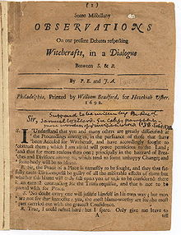
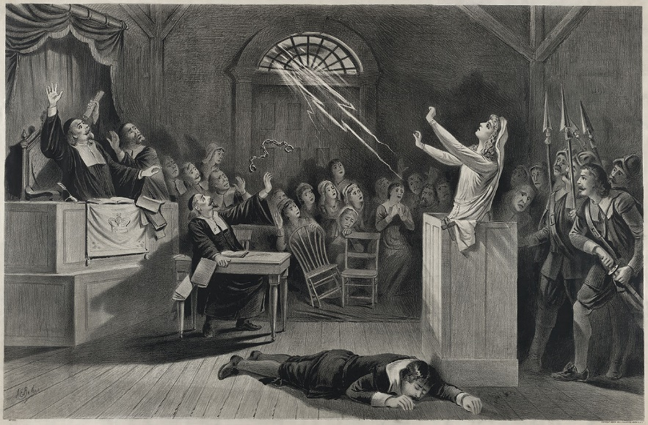
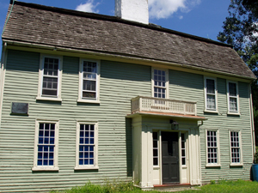
The Putnam House was originally built around 1648 on 100 acres of farm land owned by Thomas

