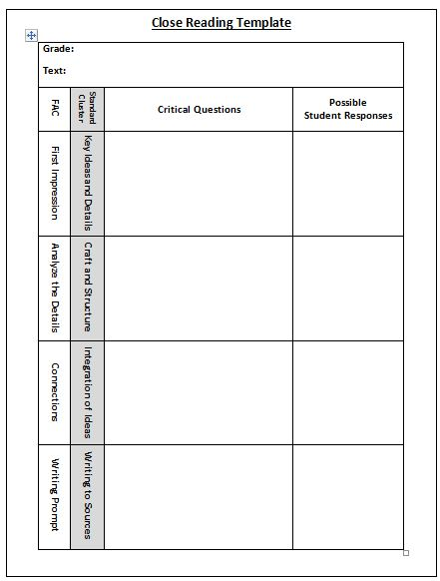

11 Members of Group _________________________________________  
 ________________________________________

1. What clues do you get from the title?   
  
  
  
2. What creation is being explained? (main idea)

Describe the story plot/structure (use space below and in this response column)  
  
Setting-  
Problem/Conflict that causes the rising action-  
  
Climax/Turning Point (brings change)-  
  
Resolution/Outcome-  
  
What is the lesson or moral of the story?  
  
  
  
How does this explanation of how something was created differ from yours?  
  
  
  
  
What do you know about the author(s) and their background?