Boise cartoonist reacts to Charlie Hebdo attack
http://www.ktvb.com/story/news/local/2015/01/11/boise-cartoonist-reacts-to-charlie-hebdo-attack/21582745/
Stephanie Zepelin, KTVB10:25 p.m. MST January 10, 2015
BOISE -- Thousands of people in Paris have been rallying in solidarity with those affected by the Charlie Hebdo shootings, too. While Boise doesn't have a magazine that takes their satire as far as Charlie Hebdo, the Boise Weekly does run political cartoons.
Charlie Hebdo regularly waded into controversial waters for political and religious cartoons, some of which portrayed the Muslim Prophet Muhammad.
"They're attacking Muhammad, and they should absolutely be able to do that, and I think that's inalienable rights of course, to be able to say that." said Elijah Jensen-Lindsey, whose comic Hobo Jargon appears in the Boise Weekly.
Jensen-Lindsey entered a contest at the Boise Weekly in 2008 and won. Several years later, they decided to make Hobo Jargon a permanent fixture.
"I would hate to compare what I do to anything that is happening there," said Jensen-Lindsey. "They are taking much more of a stand than I ever will for freedom of speech."
The Idaho native realizes that if he upset someone enough with his work, they could find him and attack him, which is why he tries to be more subtle with his messages.
"Really in terms of making a cogent, long-lasting statement, I feel like there's more nuance, is one thing we have to take into account in terms of the context and where we are in society," Jensen-Lindsey said.
He hopes people use their right to free speech to make people think, not just to make people angry.
"It's impossible to gauge, but I hope that the things that were printed did create positive change and did somehow bring people together and raise awareness," said Jensen-Lindsey "Otherwise it's a waste of time really."
Now the rest of the staff at the magazine, the people of France, and everyone who has been following this story has the task of figuring out how to move forward.
"I think my opinion of it right now is that we need to fight harder than ever in support of freedom of speech," Jensen-Lindsey said. "But we need to really focus on how to do that most properly and in a way that's healing and moves forward."
Jensen-Lindsey is doing a special cartoon for this Wednesday's Weekly that will reflect the issues brought up by the Charlie Hebdo attack.

Firebombing at German paper that ran Charlie Hebdo cartoons

By Deborah Cole18 hours ago http://news.yahoo.com/arson-attack-german-paper-ran-charlie-hebdo-cartoons-065348454.html
Berlin (AFP) - A German tabloid that paid tribute to those killed at Charlie Hebdo by reprinting cartoons from the French satirical paper mocking the Prophet Mohammed was firebombed Sunday, police said.
With security services on high alert after a jihadist killing spree in Paris, police in the northern German port city of Hamburg said no one was at the headquarters of the regional daily Hamburger Morgenpost at the time of the attack, which caused only slight damage. Hamburg police said it was "too soon" to tell whether there was a connection between the Charlie Hebdo tribute and the firebombing, which would be the first attack against the cartoons since Wednesday's massacre of 12 people at the French weekly.
"Rocks and then a burning object were thrown through the window," a police spokesman told AFP.
The Hamburger Morgenpost, known locally as the MOPO, had splashed the Charlie Hebdo cartoons on its front page after the massacre at the Paris publication with the headline "This much freedom must be possible!".
Police said the attack had occurred at about 0120 GMT and that two men, aged 35 and 39, seen acting suspiciously near the scene were detained and are being questioned. The newspaper, which has a circulation of around 91,000, offered regular updates on the firebombing on its website.
"Thick smoke is still hanging in the air, the police are looking for clues," it said in its initial story, under the headline "Arson attack on the MOPO - Due to the 'Charlie Hebdo' cartoons?".
Later Sunday it had removed any reference to Charlie Hebdo but quoted the regional representative body for the media as calling the attack a "cowardly and insidious act of terror against press freedom". Editor-in-chief Frank Niggemeier said in a statement said his team was "shocked that something like this could happen in a cosmopolitan and liberal city like Hamburg". Hamburg is Germany's second city, with a population of around 2.4 million.
- Solidarity with French cartoonists - Several European newspapers ran the cartoons featuring the Prophet Mohammed on their front pages in a gesture of solidarity with the murdered French cartoonists and in defence of free speech. On Sunday the offices of a Belgian newspaper that published the cartoons were evacuated after it received an anonymous bomb threat, its staff said.The Hamburg firebombing comes at a time of heightened tensions over the rise of a new anti-Islamic movement in Germany.
The right-wing populist group, "Patriotic Europeans Against the Islamisation of the Occident"(PEGIDA), has called for its 12th weekly march in the eastern city of Dresden Monday to be dedicated to "the victims of terrorism in Paris". Hamburg's Islamist scene came to global attention in 2001 when it emerged that three of the suicide hijackers from the September 11 attacks on the United States, including ringleader Mohammed Atta, had lived and studied in the city.

These Are The Charlie Hebdo Cartoons That Terrorists Thought Were Worth Killing Over
The Huffington Post | By Catherine Taibi http://www.huffingtonpost.com/2015/01/07/charlie-hebdo-cartoons-paris-french-newspaper-shooting_n_6429552.html Posted: 01/07/2015

Gunfire broke out Wednesday in an attack at the offices of French satirical weekly Charlie Hebdo, leaving 12 dead, including four prominent cartoonists. Known for its caricatures of the Prophet Muhammad, as well as critical depictions of Catholics, Jews and French politicians, the magazine regularly stirred controversy. Charlie Hebdo gained notoriety in 2006 for its portrayal of a sobbing Muhammad, under the headline "Mahomet débordé par les intégristes" ("Muhammad overwhelmed by fundamentalists"). Within its pages, the magazine published 12 cartoons of the Prophet Muhammad, bringing unprecedented condemnation from the Muslim world. The French Council for the Muslim Faith eventually sued the weekly for the cartoon. The issue has since been considered the one which positioned Charlie Hebdo as a target for terrorist attacks.
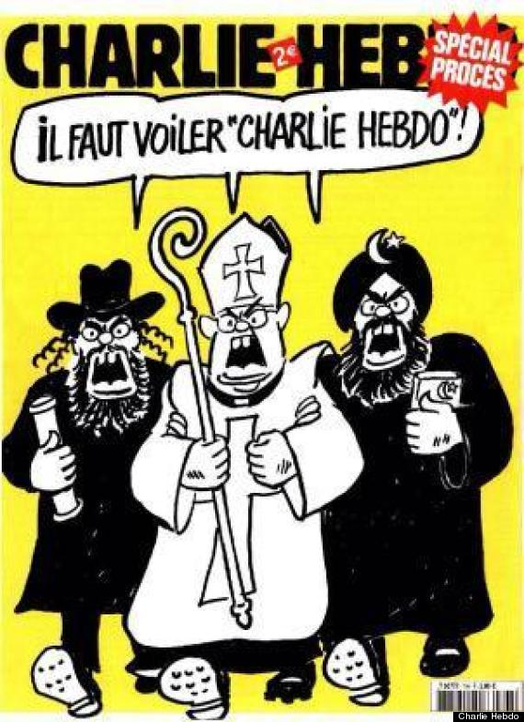
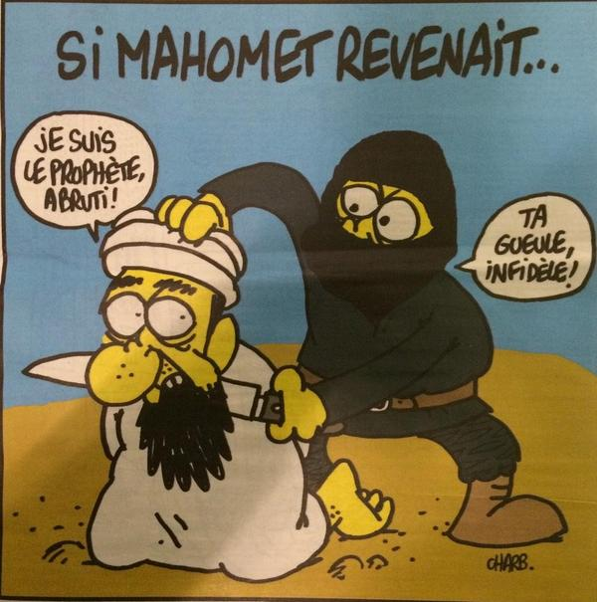
Before a French court sided with Charlie Hebdo in the lawsuit, in 2007, another cartoon was published with the text "Charlie Hebdo must be veiled!"
Charlie Hebdo's website was hacked following a 2011 cartoon depicting the Prophet Muhammad as gay.
In 2011, headlined by a cartoon reading "100 lashes if you don't die of laughter," an issue invited Muhammad to be a "guest editor" for the weekly. The Charlie Hebdo offices were firebombed following its publication.Muhammad.
In a more recent issue, the magazine published a cartoon depicting a member of the Islamic State group beheading Muhammad.

'Boyhood' prevails in Golden Globes that may alter Oscar race
By Mary Milliken and Piya Sinha-Roy7 hours ago
The night took on a more somber tone from the beginning when stars like George Clooney and Helen Mirren showed their support for free expression and the victims of a deadly attack on a satirical French newspaper last week. The president of the Hollywood Foreign Press Association, which organizes the Globes, brought the room to a standing ovation by saying: "Together we will stand united against anyone who would repress free speech anywhere from North Korea to Paris." Hosts opened with a joke about the cyberattack, which the U.S. government has blamed on North Korea. The country, which denies it is behind the hacking, was angered over the studio's comedy "The Interview," which depicts the assassination of leader King Jong Un.

